Physiotherapy Self Referral Form - Confidential information

For physiotherapy at the RAH please complete this form and post or hand it in to:
Royal Alexandra Hospital, Physiotherapy Dept, Corsebar Road, Paisley, PA2 9PN

(This form is not for under 14’s /if you are pregnant /need a home visit or therapy at Johnstone /Renfrew Health Centre).

Name: _________________________________Date of birth: _____________ Date:____________

Address: _________________________________________________________________________

Postcode: __________ Tel:___ _ __(Home)_____ ____________________(Work / Mobile)
GP’s name:___________________________GP practice:________________________________
Do you need an interpreter? No□ Yes □ What language? _______________________________
Why do you want physiotherapy? You can use the picture below to show us where your problem is.

a) How long have you had this problem?
< 2 weeks□ 2 - 6 weeks□ 6 -12 weeks□ >12weeks□
b) How would you describe your pain?
No pain□ Mild□ Moderate□ Severe□
c) Are there times in the day when you have no pain? Yes□ No□
d) Is the pain significantly disturbing your sleep? Yes□ No□
e) Is your problem getting? Worse□ Better □ Not changing□
f) Are you off work with this problem? Yes□ No□
If yes how long for? ______________
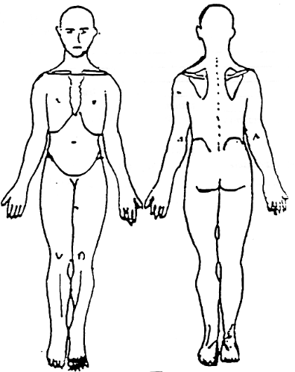
From the start of this problem, have you any of the following? *If yes please also consult your GP.

*Tingling /numbness or weakness in both arms / legs Yes□ No□ ______________________________
*Changes to your bladder or bowel Yes□ No□ ___________________________________________
*Difficulty swallowing Yes□ No□_______________________________________________________
*Double vision Yes□ No□ __________________________________________________________
*New Headaches Yes□ No□ ________________________________________________________
*Dizziness / loss of balance / black outs Yes□ No□ _______________________________________
*Unexplained weight loss Yes□ No□ __________________________________________________

Have you personally had cancer? Yes□ No□ ________________________________________
What other medical conditions do you have?

What medication are you currently using?

